NAME:Rishik JK
REG.NO :192511052

CSA1702-ARTIFICIAL INTELLIGENCE
LAB EXPERIMENT

24. Prolog Program to Suggest Dieting System Based on Disease

1. Aim
To write a Prolog program to suggest suitable food items based on a person's disease.

2. Algorithm
- Start the program.
- Define diseases and their recommended food items.
- Create a rule to suggest food based on disease.
- Give the disease name as input.
- Display the recommended food.
- Stop.
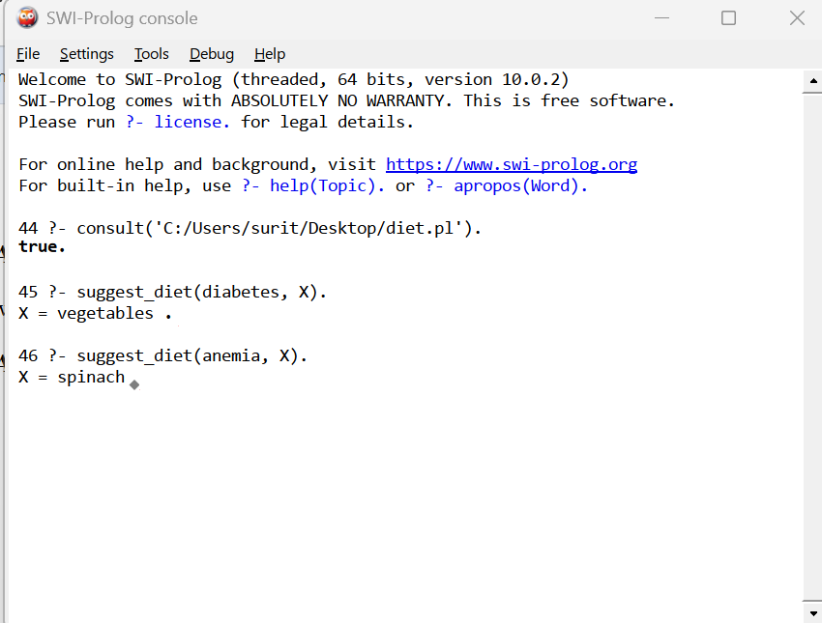

6. Result
Thus, the Prolog program to suggest food items based on a disease was successfully implemented and executed.

